Dublin Juvenile Uneven Age, Junior and Senior Championships
November 1st
These races will be held in Tymon Park, in the north corner of the park between Greenhills Road and Lugnaquilla Avenue.
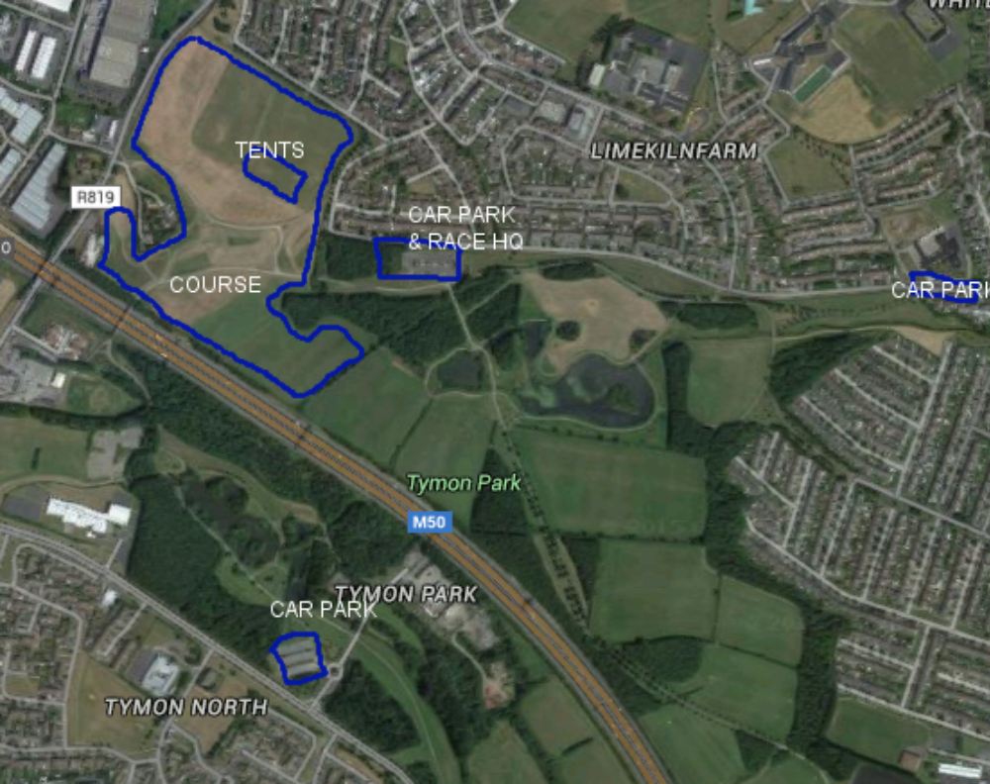
The closest car park is on Limekiln Road. There is more parking outside St Peters national school further down Limekiln Road, and in a second Tymon Park car park off Castletymon Road. These secondary car parks are 10/15 minutes walk from the race location.

Directions from the M50 to the Limekiln Road car park are at this link
https://www.google.ie/maps/dir/53.2970307,-6.3348533/53.3050243,-6.3404457/@53.3004746,-6.3302817,14z/am=t/data=!4m4!4m3!1m0!1m0!3e0

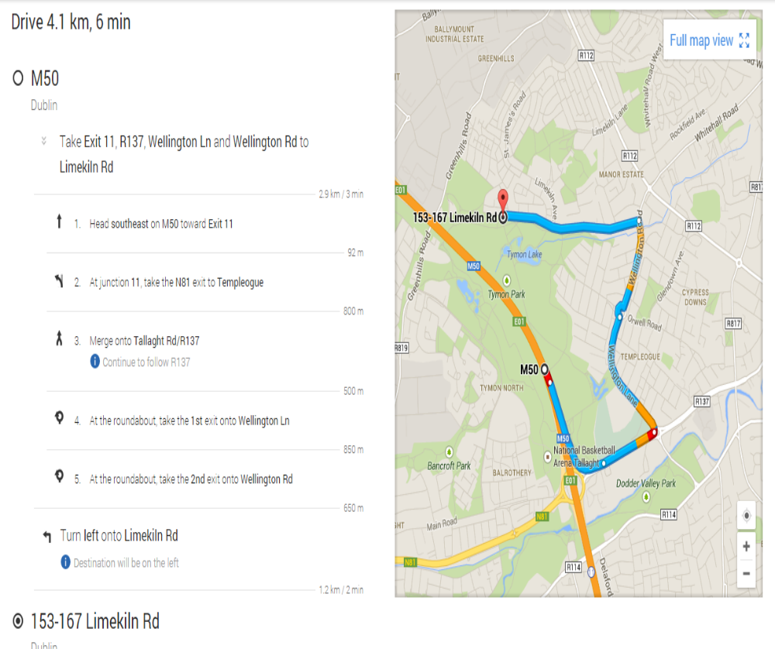

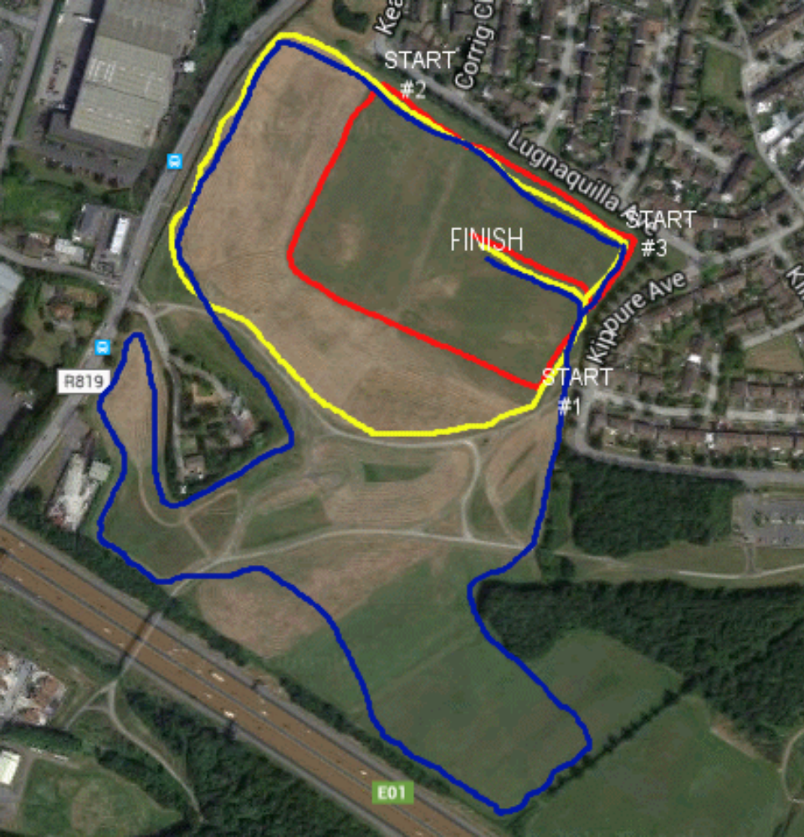

Race | Distance | Start | Course | Time
Under 9 | 800m | #1 | One red lap | 11.00am
Under 11 | 1500m | #3 | Two red laps | 11.15am
Under 13 | 2500m | #2 | Complete the red lap then two yellow laps | 11.35am
Under 15 | 3500m | #2 | Complete the red lap, one yellow lap, one blue lap | 12.05pm
Under 17 girls | 4000m | #3 | Two blue laps | 12.45pm
Under 17 boys | 5000m | #3 | One yellow lap, two blue laps | 1.05pm
Junior women | 3000m | #3 | One yellow lap, one blue lap | 1.35pm
Junior men | 6000m | #3 | Three blue laps | 1.55pm
Senior women | 6000m | #3 | Three blue laps | 2.30pm
Senior men | 10000m | #3 | Five blue laps | 3pm

