1500m
Dublin Cross Country Championship Santry - 6th November 2016

980m
Finish

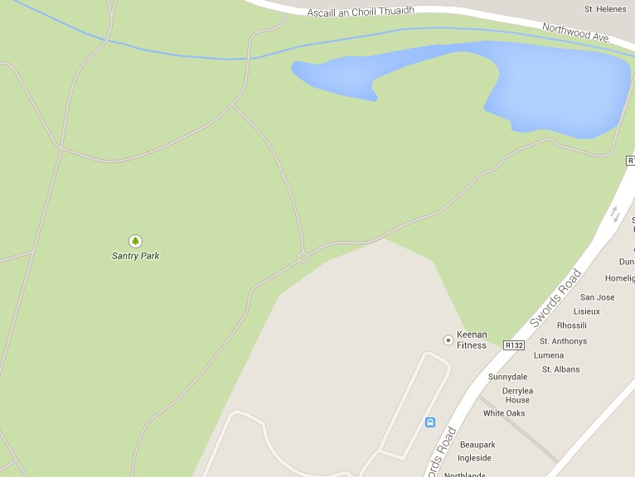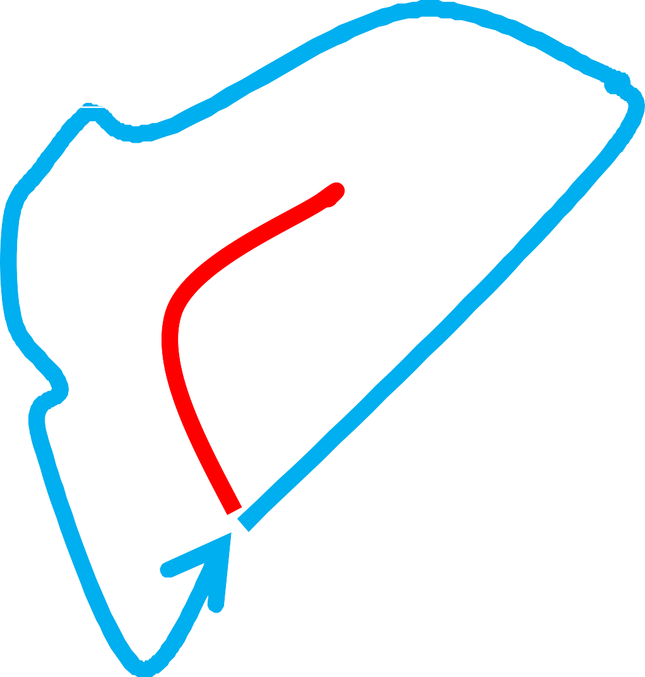

Start
U9 Girls | 800m | 1 Blue Dotted Loop
U9 Boys | 800m | 1 Blue Dotted Loop
U11 Girls | 1500m | 1 Orange Loop
U11 Boys | 1500m | 1 Orange Loop
U13 Girls | 2500m | 1 Blue Loop + 1 Orange Loop
U13 Boys | 2500m | 1 Blue Loop + 1 Orange Loop
U15 Girls | 3500m | 2 Blue Loops+ 1 Orange Loop
U15 Boys | 3500m | 2 Blue Loops + 1 Orange Loop
U17 Girls | 4000m | 1 Blue Loops + 2 Orange Loops
U17 Boys | 5000m | 2 Blue Loops + 2 Orange Loops
U/19/Junior Ladies | 4000m | 1 Blue Loop + 2 Orange Loops
U/19/Junior Men | 6000m | 4 Orange Loops
Senior Ladies | 6000m | 4 Orange Loops
Seior Men | 10000m | 1 Blue Loop + 6 Orange Loops

Officials car parking at Clonliffe Harriers

Stadium for event car parking

